1. Requesting Organization

Name:
Address: | Tegucigalpa, Honduras

Describe the role/mandate of the organization

Year of establishment: 2006
Size of organization:
Number of staff: 15 members

Other pertinent information:

Field of activity:

Is your organization assisted/funded by other organizations/companies:

Assignment Terms of Reference

Assignment title:

Preamble :
This post is a United Nations Volunteers programme assignment and based on the values of free will, commitment, engagement and solidarity, which are the foundations of volunteerism. Volunteering brings benefit to the individual volunteer. It makes important contributions, economically, as well as socially. It contributes to creating social cohesion and capital, through helping to build trust and reciprocity among citizens.

The United Nations Volunteers is the UN Organization that supports sustainable human development globally through the promotion of volunteerism and mobilization of volunteers. It serves the causes of peace and development through enhancing opportunities for participation by all peoples. It is universal, inclusive and embraces volunteer actions in all its diversity.

Volunteerism is diverse and is embedded in all cultures and traditions. In this context, as a United Nations Volunteer you are encouraged and expected to relate to local volunteerism and to be identified with the concept. You are expected to regard your national colleagues as peers and together uphold trust as volunteers among yourselves and within the communities and the organization you are assigned to.

Detailed Terms of Reference (Please describe in as much detail as possible the services required from the University Volunteer(s) and how their contribution will fit into the organization’s plans.)

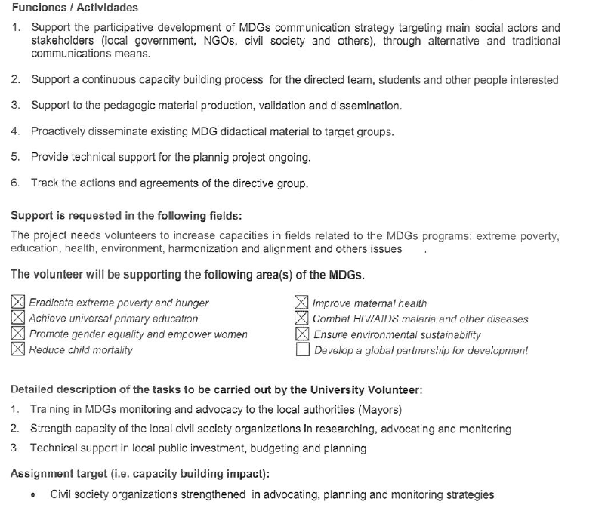
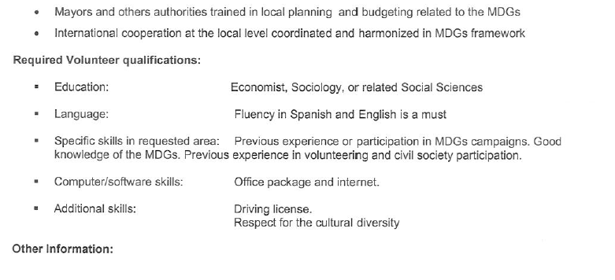
Location of assignment: Santa Rosa de Copán (west region)

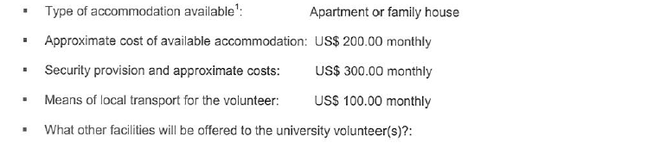

Visa requirements:______ visa needed____________________________________________________________________________________________________________

The accommodation for university volunteers has to be compliant with the Minimum Operating Residential Security Standards (MORSS). It needs to be cleared by the UN Field Security Officer prior to the fielding of the volunteers. They need to be estimated or budgeted at the TOR request when filling the form, if any.

