1. Requesting Organization

Name: | Centro de Desarrollo Humano
Address: | Tegucigalpa, Honduras

Describe the role/mandate of the organization

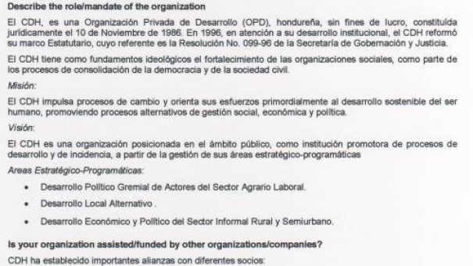
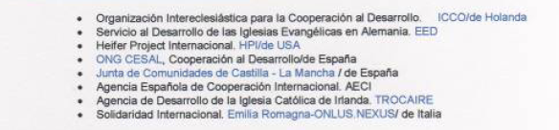

Assignment Terms of Reference

Assignment title:

Preamble :
This post is a United Nations Volunteers programme assignment and based on the values of free will, commitment, engagement and solidarity, which are the foundations of volunteerism. Volunteering brings benefit to the individual volunteer. It makes important contributions, economically, as well as socially. It contributes to creating social cohesion and capital, through helping to build trust and reciprocity among citizens.

The United Nations Volunteers is the UN Organization that supports sustainable human development globally through the promotion of volunteerism and mobilization of volunteers. It serves the causes of peace and development through enhancing opportunities for participation by all peoples. It is universal, inclusive and embraces volunteer actions in all its diversity.

Volunteerism is diverse and is embedded in all cultures and traditions. In this context, as a United Nations Volunteer you are encouraged and expected to relate to local volunteerism and to be identified with the concept. You are expected to regard your national colleagues as peers and together uphold trust as volunteers among yourselves and within the communities and the organization you are assigned to.

Detailed Terms of Reference (Please describe in as much detail as possible the services required from the University Volunteer(s) and how their contribution will fit into the organization’s plans.)

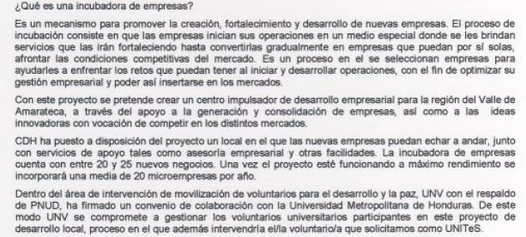
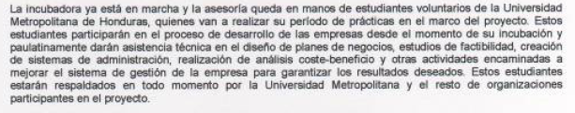

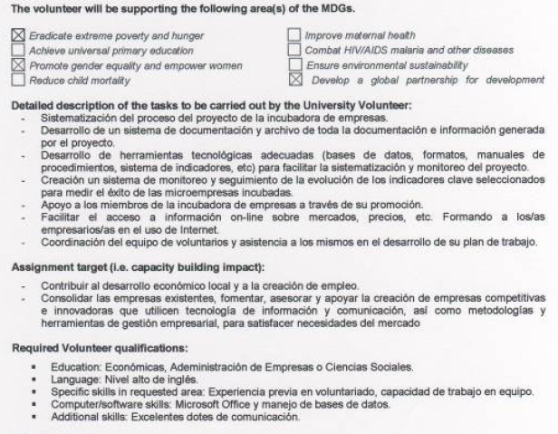
Location of assignment: Tegucigalpa, Honduras


Visa requirements:______ visa needed____________________________________________________________________________________________________________

