1. Requesting Organization

Name: | Libre Expresión
Address: | Tegucigalpa, Honduras
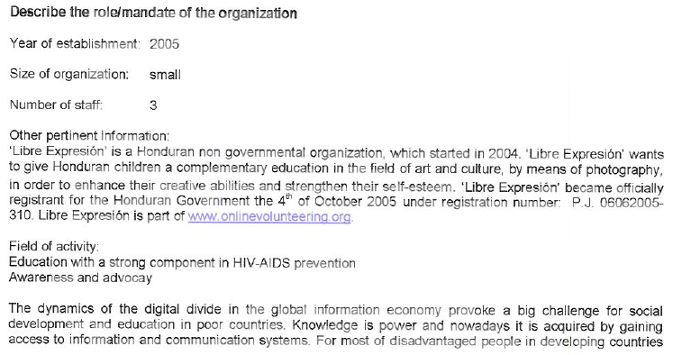
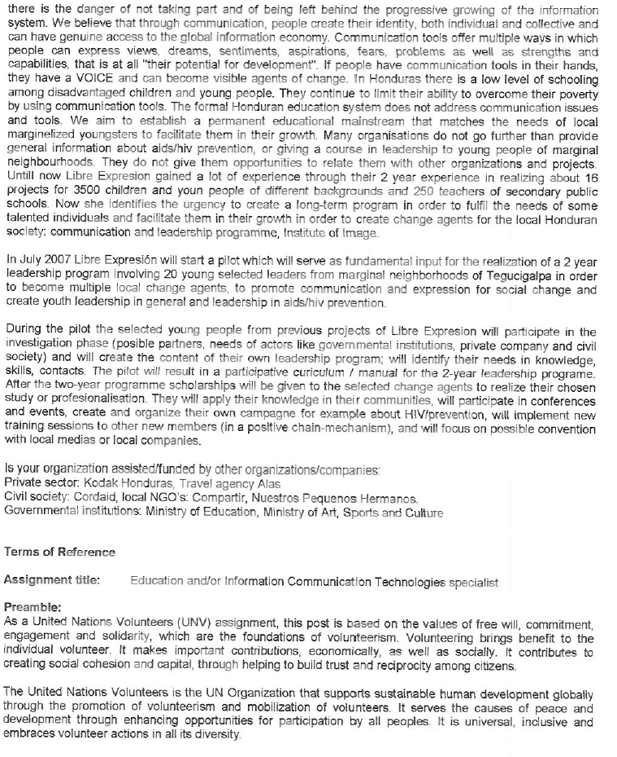
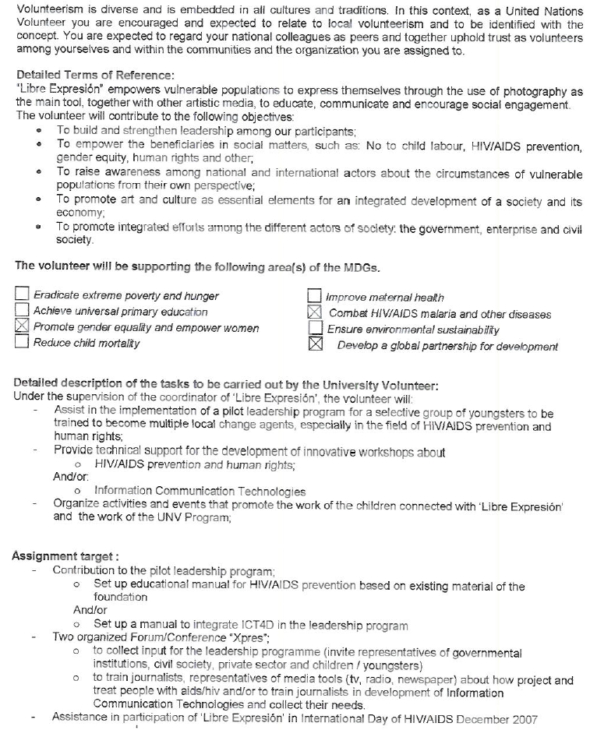
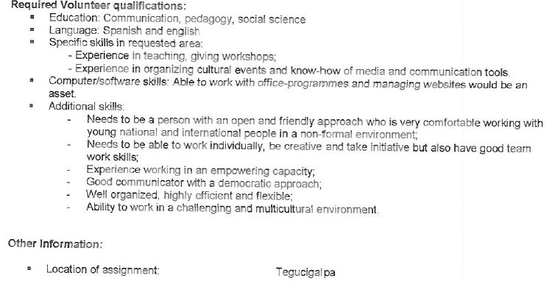

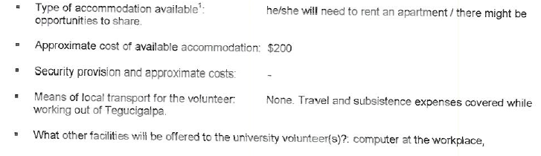

Visa requirements:______ visa needed____________________________________________________________________________________________________________

The accommodation for university volunteers has to be compliant with the Minimum Operating Residential Security Standards (MORSS). It needs to be cleared by the UN Field Security Officer prior to the fielding of the volunteers. They need to be estimated or budgeted at the TOR request when filling the form, if any.

