1. Requesting Organization

Name: | Asociación Cultural Arte Acción
Address: | Tegucigalpa, Honduras
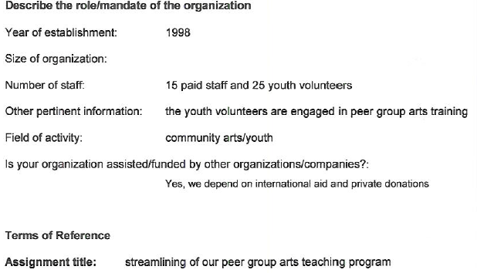

Preamble
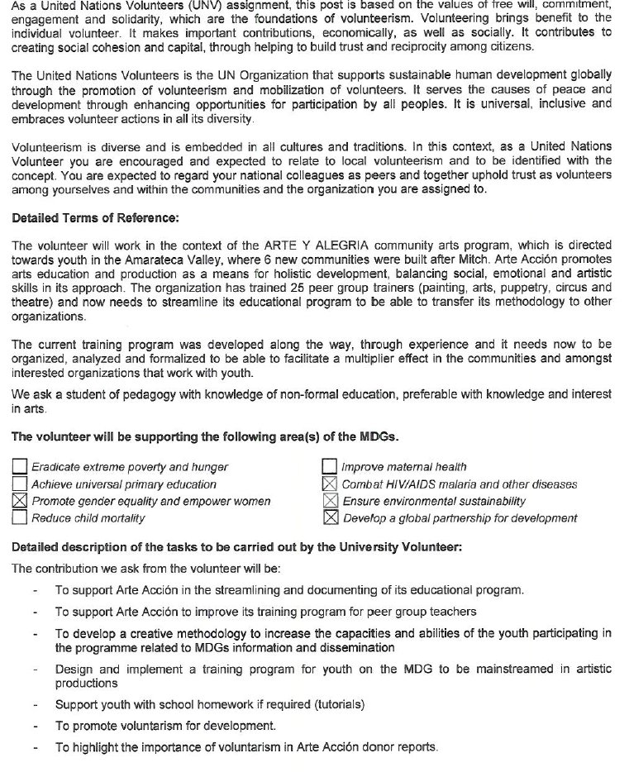

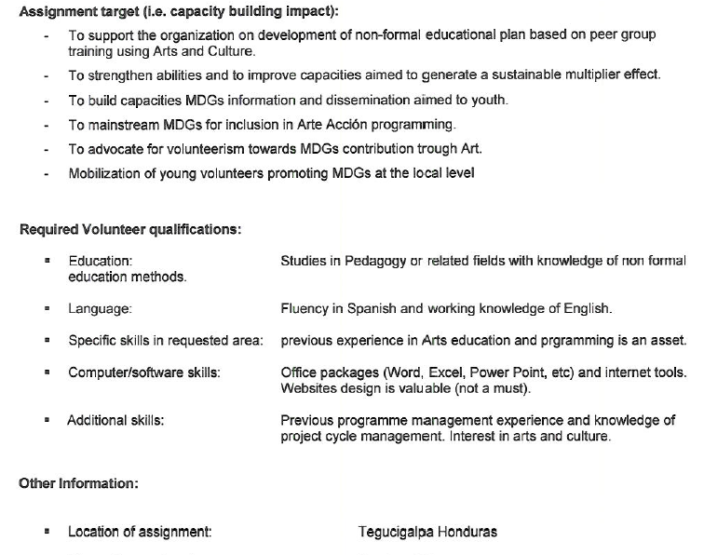
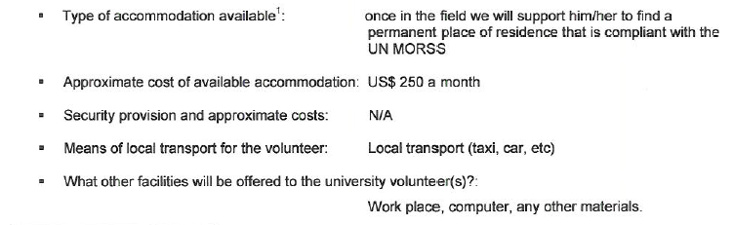

The accommodation for university volunteers has to be compliant with the Minimum Operating Residential Security Standards (MORSS). It needs to be cleared by the UN Field Security Officer prior to the fielding of the volunteers. They need to be estimated or budgeted at the TOR request when filling the form, if any.

